Non- Credit Course

1. we add Grades Setup for Non Credit Course.

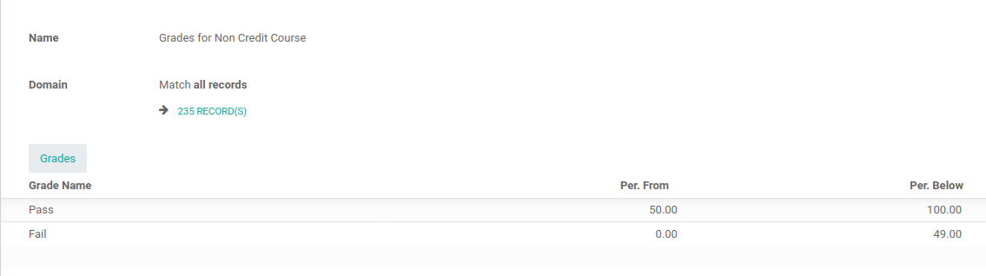

2. Set Credit of course is zero and contact hours 2.
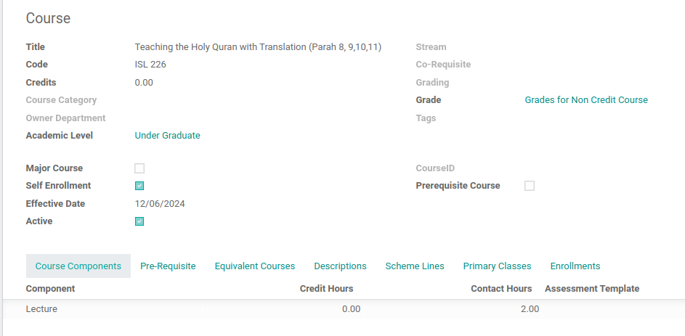

After assigning grades, it shows all students as failed. However, if we set the credits to 2, it displays them as either pass or fail.
It is non-credit courses mean zero credits and also there is no effect GPA.
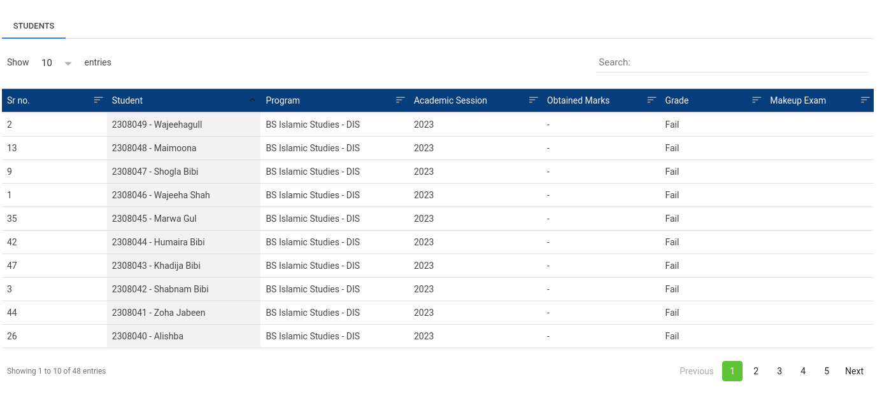

There is one more issue: the grades are assigned using two buttons, SAVE and ASSIGN GRADES. It should only work with the ASSIGN GRADES button.

